Head Shaping in the Open Crib
Infant on square pillow with head in midline
Use large tube WITH straps to keep head in midline
Use small tube WITHOUT straps at feet of baby

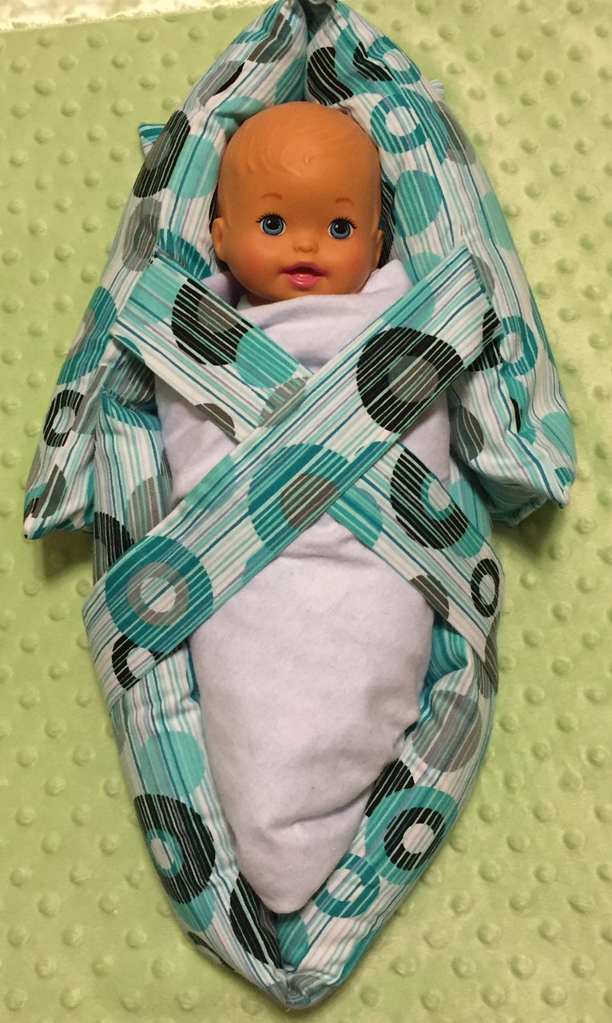
www.shaperight.net

